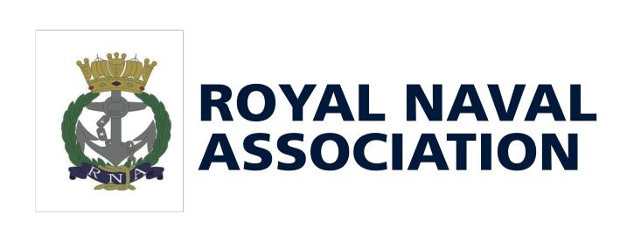Association Patron: Her Majesty the Queen.

Incorporated by Royal Charter. Full recognition by the Royal Navy.
RNA PLYMOUTH

Registered Charity No. 1070422

RNA No.4 AREA ANNUAL GENERAL MEETING/AREA MEETING.

THE MEETING WILL TAKE PLACE ON JANUARY 19TH 2019

AT THE KINGS TAMERTON COMMUNITY CENTRE

TREVITHICK ROAD, KINGS TAMERTON. PL5 2BU.

COMMITTEE MEETING WILL CONVENE AT 11.00, AGM AT 13.30 FOLLOWED BY THE AREA MEETING. TO REACH THE VENUE PROCEED ON THE A38 TO THE ST. BUDEAUX TURN OFF.

- FROM EXETER TAKE THE FIRST LEFT (ROMAN WAY) , CONTINUES ON TO TREVITHIC ROAD, CENTRE SITUATED ON THE LEFT HAND SIDE.

- FROM CORNWALL FIRST EXIT AFTER TAMAR BRIDGE.TAKE FOURTH EXIT ON FIRST ROUNDABOUT AND FIRST EXIT ON SECOND ROUNDABOUT (ROMAN WAY). CONTINUE AS ABOVE.

LUNCHTIME. PLOUGHMANS £ 3.00 OR A PASTY £3.00

TO BE ORDERED IN ADVANCE. WILL BE AVAILABLE AT LUNCHTIME.

PLEASE INFORM BRANCH SECRETARY OF REQUIREMENT BY THE 5TH JANUARY.

CHEQUES PAYABLE TO RNA PLYMOUTH.

NOTE: (THERE ARE NO SHOPS OR RESTAURANTS WITHIN WALKING DISTANCE)

……………………………………………………………………………………………………………………………………………………………………………

……………………………………………………… BRANCH WILL BE*/WILL NOT* BE ATTENDING THE MEETING.

 | (DELETE AS APPROPRIATE)
NAME(S)…………………………………………………………. | BRANCH ……………………………………………….
LUNCHTIME PLOUGHMANS (£3.00) QTY…………. | LUNCHTIME PASTY (£ 3.00) QTY………….

PLEASE RETURN TO: HON.SECRETARY, RNA PLYMOUTH, 4 ROWAN COURT, LATCHBROOK, SALTASH PL12 4UN.

Royal Naval Association. Registered Charity No. 1070422.

Hon.Secretary. Arthur Gutteridge BEM,

‘Chendera’, 4,Rowan Court, Latchbrook, Saltash, Cornwall. PL12 4UN E: artsue@virginmedia.com T (01752) 849176

ACCOMMODATION

• COPTHORNE HOTEL, PLYMOUTH

01752 224161

BED & BREAKFAST FROM £61.79

**********

- JURY’S INN, PLYMOUTH

01752 631000

BED & BREAKFAST FROM £59.20

**********

- TRAVEL LODGE, MARSH MILLS, PLYMOUTH

ROOM ONLY £

FROM £57.00

**********

• IBIS HOTEL, MARSH MILLS, PLYMOUTH

01752 601087

FROM £53.00 BED & BREAKFAST

**********

TRAVEL LODGE, SALTASH01752 601087

FROM £33.00 BED & BREAKFAST.

OFF AT 3 O’CLOCK CARKEEL ROUNDABOUT. FIRST ROUNDABOUT AFTER TUNNEL.

BRIDGE TOLL £1.50 EASTBOUND

